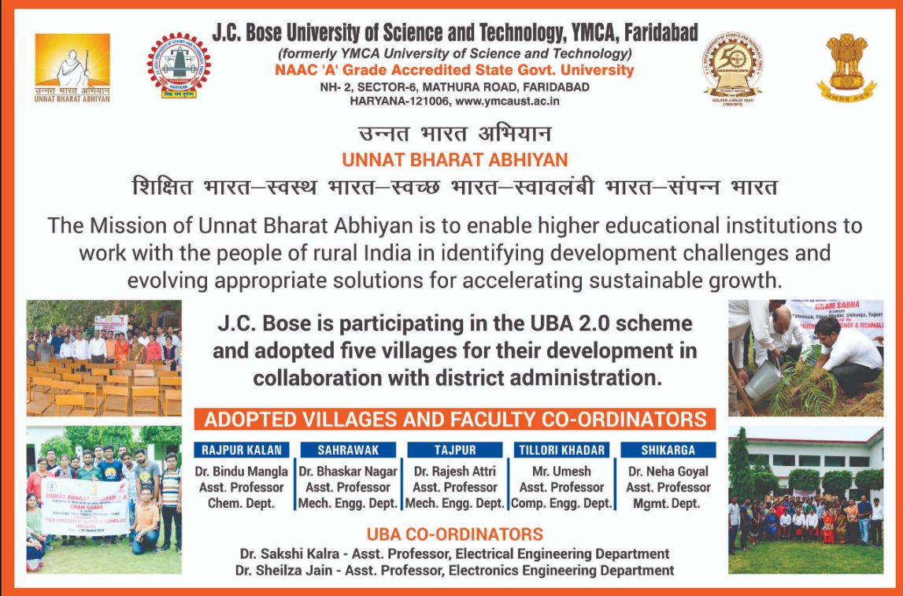

**WELCOME TO UBA CELL**

The Ministry of Human Resource Development (MHRD) has launched Unnat Bharat Abhiyan (UBA) with an aim to connect institutions of higher education with local communities to address the development challenges through appropriate technologies.

**Vision**

Unnat Bharat Abhiyan is inspired by the vision of transformational change in rural development processes by leveraging knowledge institutions to help build the architecture of an Inclusive India.

**Mission**

The Mission of Unnat Bharat Abhiyan is to enable higher educational institutions to work with the people of rural India in identifying development challenges and evolving appropriate solutions for accelerating sustainable growth. It also aims to create a virtuous cycle between society and an inclusive academic system by providing knowledge and practices for emerging professions and to upgrade the capabilities of both the public and the private sectors in responding to the development needs of rural India.

Under this scheme J.C.Bose University of Science and Technology, YMCA Faridabad has adopted 5 villages in Faridabad district. The names of the villages are:-

1. Shikarga
2. Sahrawak
3. Tajpur
4. Tilori Khadar
5. Rajpur Kalan

**Location**

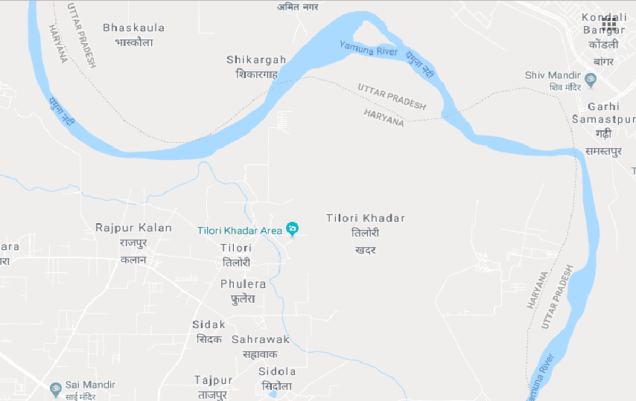

**UBA Cell Team**

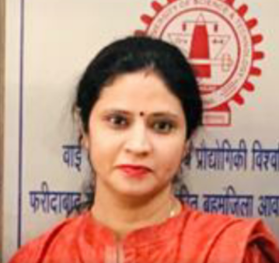  

Dr. Sakshi Kalra Dr. Sheilza Jain Dr.Umesh

UBA Coordinator UBA Co- Coordinator Faculty Coordinator

Village- Tilori Khadar

 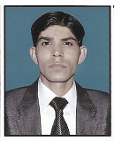 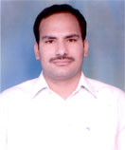

Dr. Bindu Mangla Dr. Rajesh Attri Dr. Bhaskar

Faculty Coordinator Faculty Coordinator Faculty Coordinator

Village – Rajpur Kalan Village Tajpur Village- Sahrawak

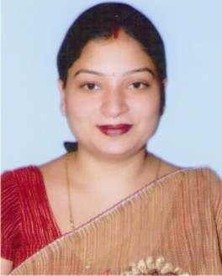  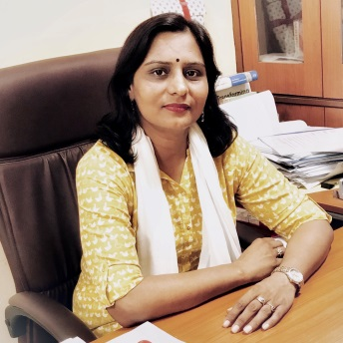

Dr. Neha Goyal Dr. Rajni Sagoo Dr. Smita

Faculty Coordinator UBA member UBA Member

Village Shikarga